Cube-Based Repeated Composite Solids

Definition
# Source: AI Source: Provided by: [Data Path: Persons Table -> ID Column: 1, Name_En Column: Motasem Essam] -> From: [ChatGPT] on [7/25/2026]
Cube-Based Repeated Composite Solids are three-dimensional geometric structures formed by joining two or more cubes in a repeated pattern or arrangement.
All components are cubes, usually with equal dimensions, although some structures may contain cubes of different sizes. The cubes can be connected face-to-face, stacked, arranged in rows or layers, or combined to create more complex three-dimensional forms.
The resulting solid may have a simple, regular structure or a complex arrangement with steps, extensions, gaps, or symmetrical patterns.

Simple Definition
# Source: AI Source: Provided by: [Data Path: Persons Table -> ID Column: 1, Name_En Column: Motasem Essam] -> From: [ChatGPT] on [7/25/2026]
A cube-based repeated composite solid is a 3D shape made by joining multiple cubes in a repeated arrangement.
For example, several identical cubes placed in a row, stacked in layers, or arranged into a larger block form cube-based repeated composite solids.

Geometric Representation
# Source: AI Source: Provided by: [Data Path: Persons Table -> ID Column: 1, Name_En Column: Motasem Essam] -> From: [ChatGPT] on [7/25/2026]
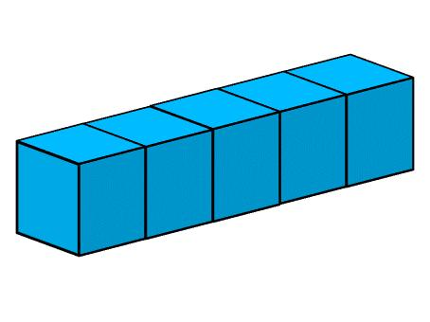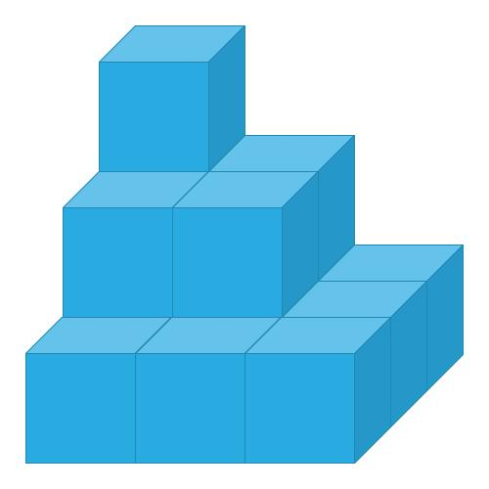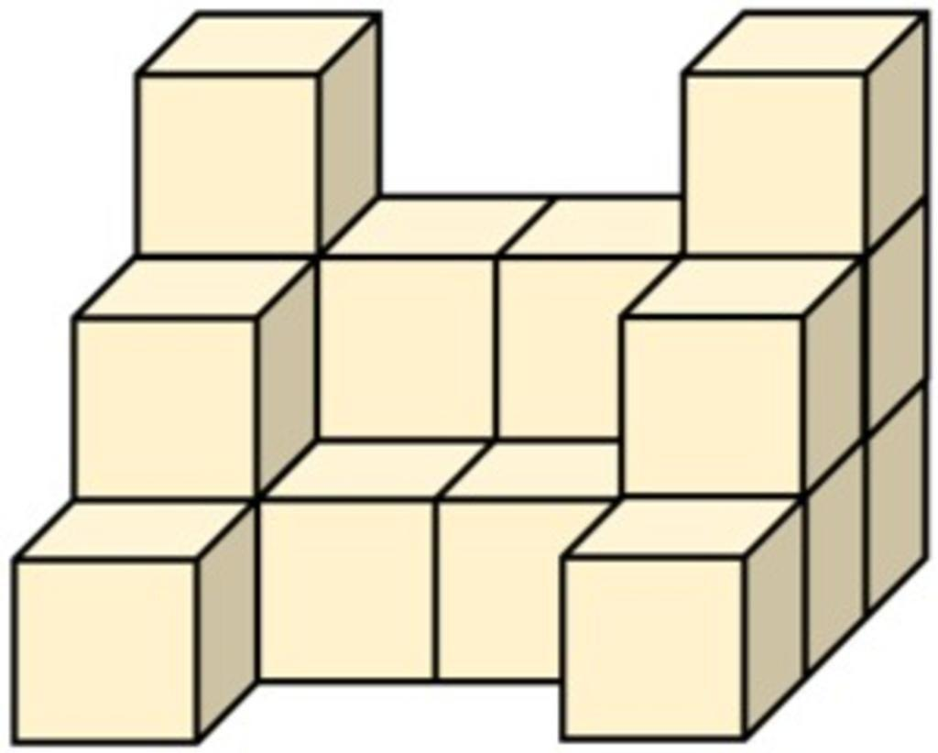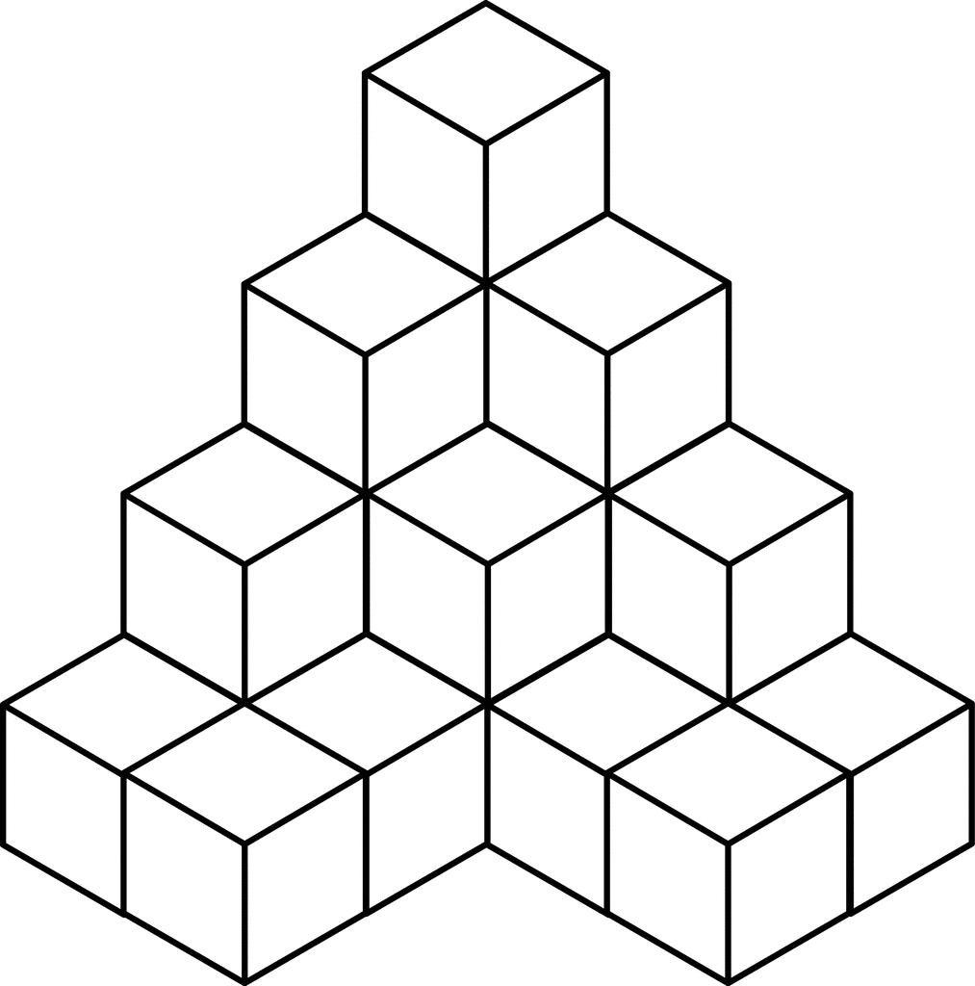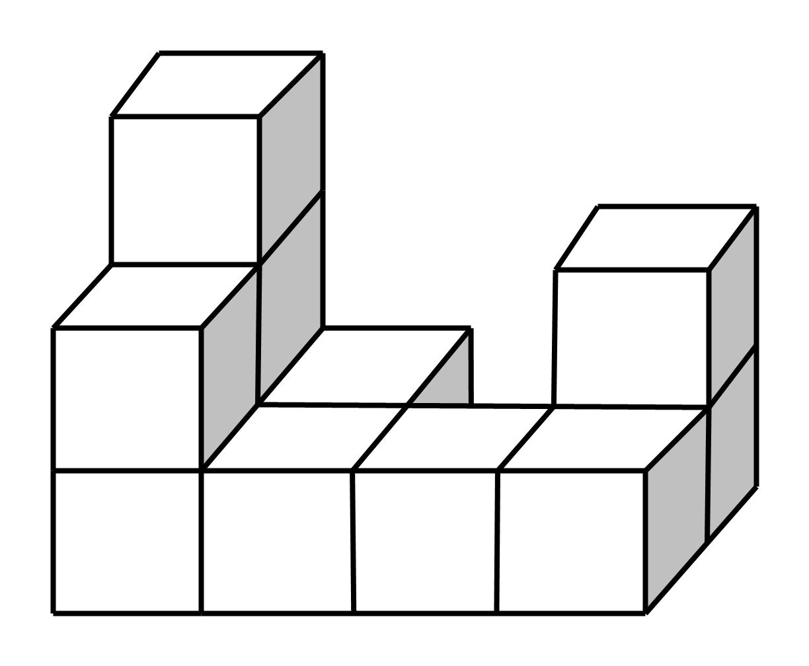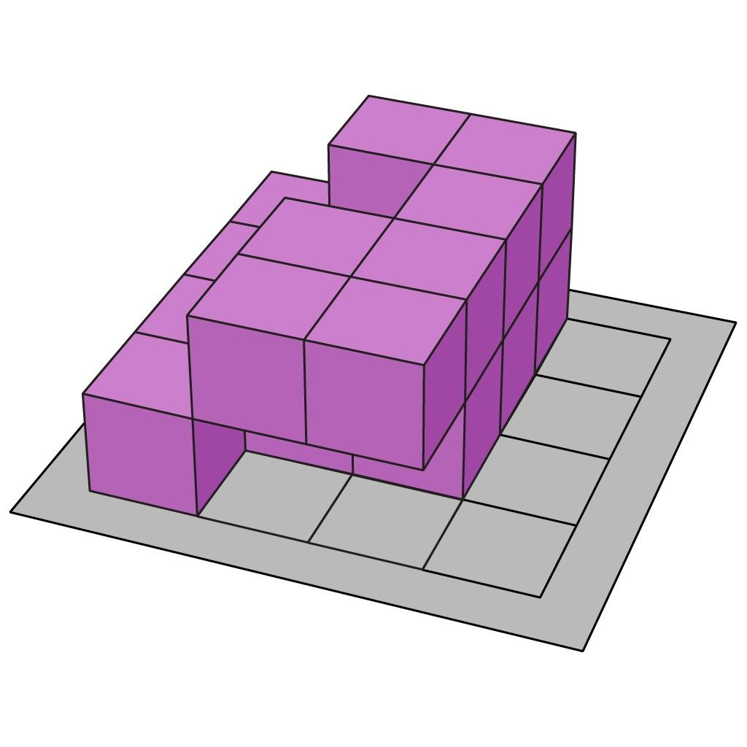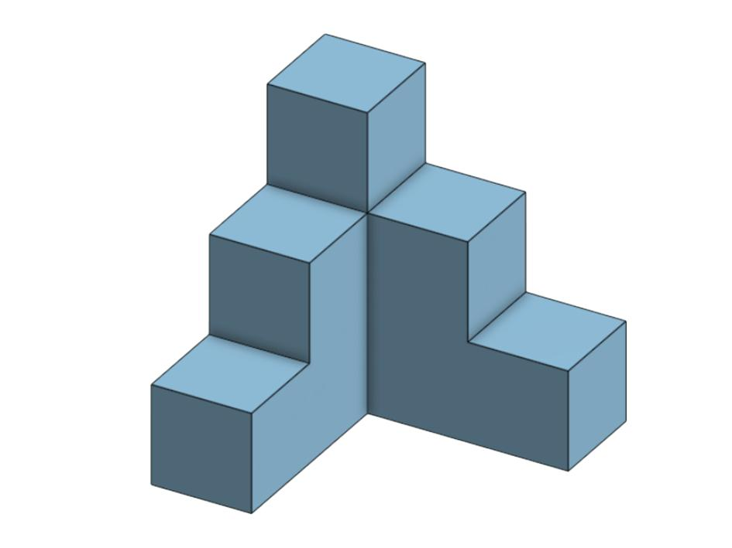
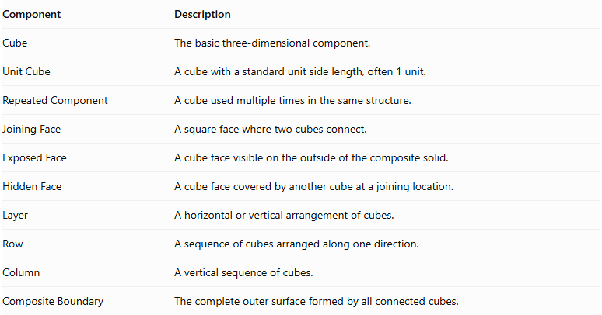
Component | Description
Cube | The basic three-dimensional component.
Unit Cube | A cube with a standard unit side length, often 1 unit.
Repeated Component | A cube used multiple times in the same structure.
Joining Face | A square face where two cubes connect.
Exposed Face | A cube face visible on the outside of the composite solid.
Hidden Face | A cube face covered by another cube at a joining location.
Layer | A horizontal or vertical arrangement of cubes.
Row | A sequence of cubes arranged along one direction.
Column | A vertical sequence of cubes.
Composite Boundary | The complete outer surface formed by all connected cubes.

Types of Cube-Based Repeated Composite Solids

Linear Cube-Based Composite Solids
# Source: AI Source: Provided by: [Data Path: Persons Table -> ID Column: 1, Name_En Column: Motasem Essam] -> From: [ChatGPT] on [7/25/2026]
Formed by joining identical cubes in a straight line along one direction.
- Horizontal linear arrangement: cubes extend horizontally.
- Vertical linear arrangement: cubes are stacked vertically.
- Depth-wise linear arrangement: cubes extend along the depth direction.

Rectangular Block Cube-Based Composite Solids
# Source: AI Source: Provided by: [Data Path: Persons Table -> ID Column: 1, Name_En Column: Motasem Essam] -> From: [ChatGPT] on [7/25/2026]
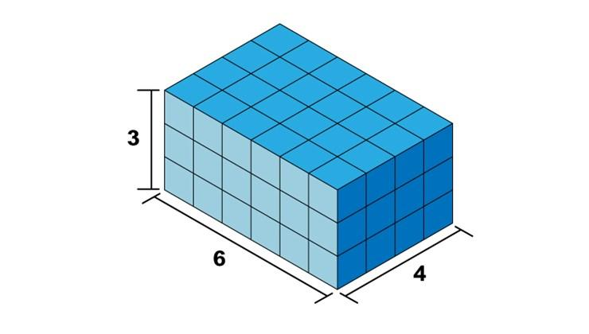
Formed by arranging cubes into a complete rectangular block with multiple rows, columns, and layers.
For example, a block containing 3 cubes in length, 2 in width, and 2 in height consists of 12 identical cubes.

Square-Layer Cube-Based Composite Solids
# Source: AI Source: Provided by: [Data Path: Persons Table -> ID Column: 1, Name_En Column: Motasem Essam] -> From: [ChatGPT] on [7/25/2026]
Formed by arranging cubes into square-shaped horizontal layers.
Examples include:
- Single square layer.
- Multiple equal square layers.
- Stacked square layers with different dimensions.

Stepped Cube-Based Composite Solids
# Source: AI Source: Provided by: [Data Path: Persons Table -> ID Column: 1, Name_En Column: Motasem Essam] -> From: [ChatGPT] on [7/25/2026]
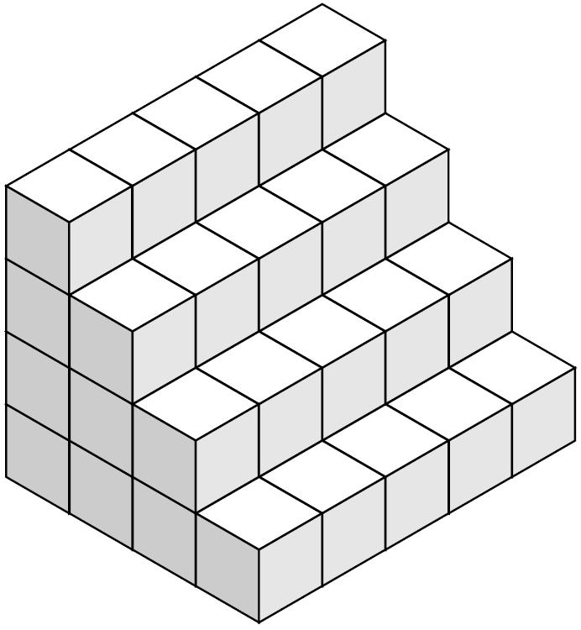
Formed by arranging cubes in successive levels, with each level having a different number of cubes.
Examples:
- Ascending stepped arrangement.
- Descending stepped arrangement.
- Symmetrical stepped arrangement.
- Multi-level stepped arrangement.

L-Shaped Cube-Based Composite Solids
# Source: AI Source: Provided by: [Data Path: Persons Table -> ID Column: 1, Name_En Column: Motasem Essam] -> From: [ChatGPT] on [7/25/2026]
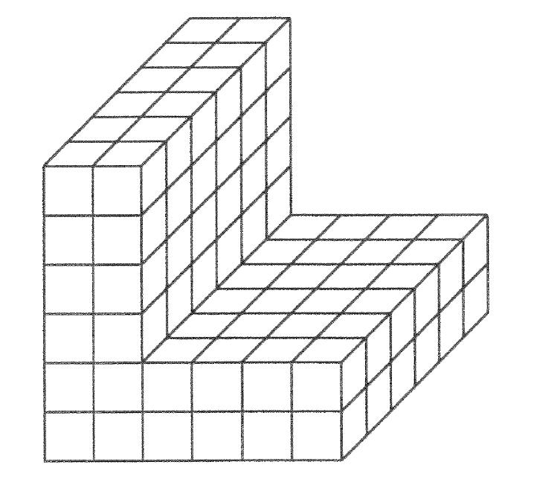
Formed by joining cubes in an arrangement that creates an L-shaped structure when viewed from a particular direction.

T-Shaped Cube-Based Composite Solids
# Source: AI Source: Provided by: [Data Path: Persons Table -> ID Column: 1, Name_En Column: Motasem Essam] -> From: [ChatGPT] on [7/25/2026]
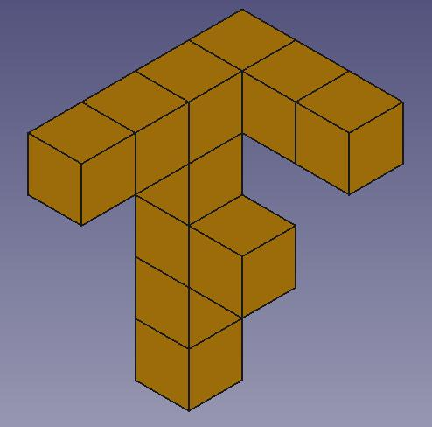
Formed by arranging cubes along a central line with an extending section that creates a T-shaped configuration.

Cross-Shaped Cube-Based Composite Solids
# Source: AI Source: Provided by: [Data Path: Persons Table -> ID Column: 1, Name_En Column: Motasem Essam] -> From: [ChatGPT] on [7/25/2026]
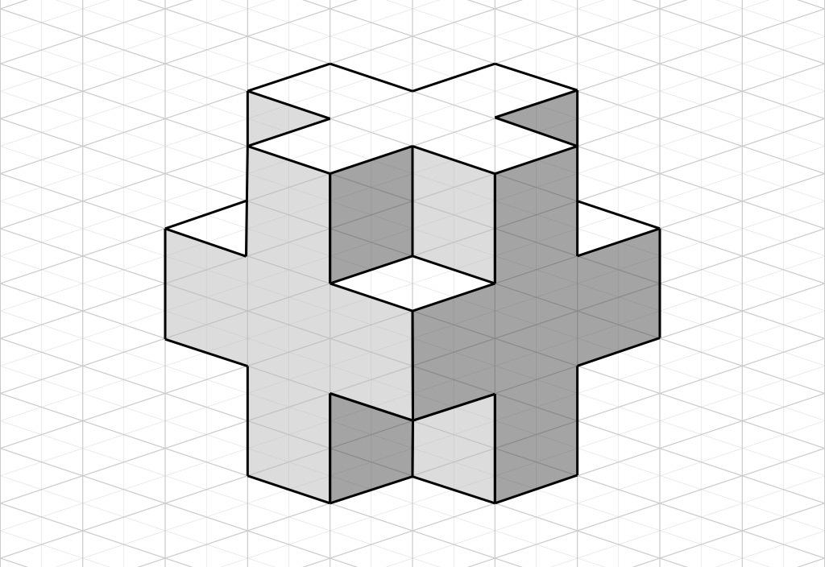
Formed by connecting cubes along multiple directions around a central cube or central section.

Staircase Cube-Based Composite Solids
# Source: AI Source: Provided by: [Data Path: Persons Table -> ID Column: 1, Name_En Column: Motasem Essam] -> From: [ChatGPT] on [7/25/2026]
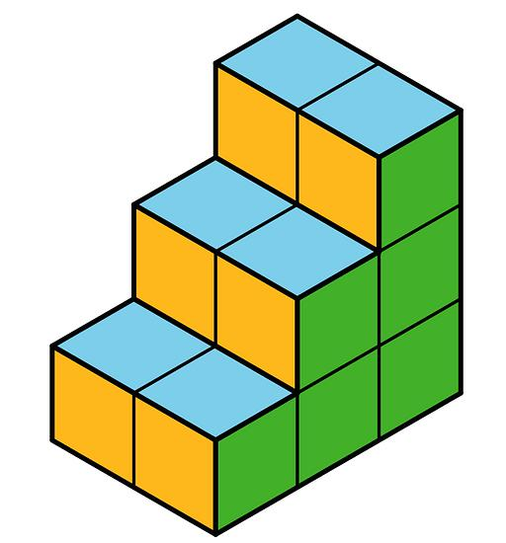
Formed by arranging cubes into a sequence of rising or descending steps, often with each successive level changing in height or length.

Pyramid-Like Cube-Based Composite Solids
# Source: AI Source: Provided by: [Data Path: Persons Table -> ID Column: 1, Name_En Column: Motasem Essam] -> From: [ChatGPT] on [7/25/2026]
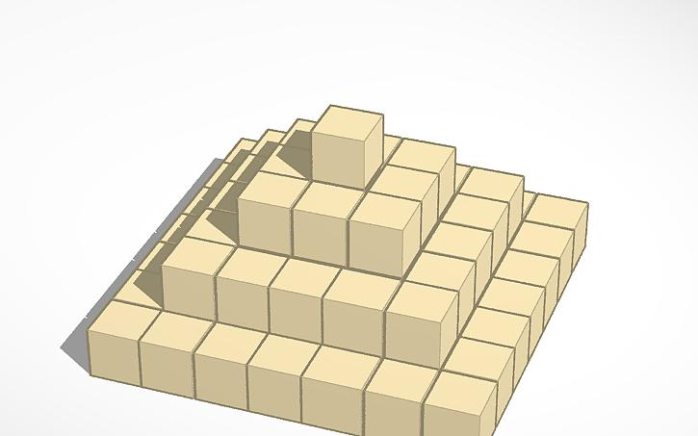
Formed by stacking progressively smaller square or rectangular layers of cubes.
Examples:
- Square stepped pyramid.
- Rectangular stepped pyramid.
- Symmetrical cube pyramid.
- Multi-layer cube pyramid.

Hollow Cube-Based Composite Solids
# Source: AI Source: Provided by: [Data Path: Persons Table -> ID Column: 1, Name_En Column: Motasem Essam] -> From: [ChatGPT] on [7/25/2026]
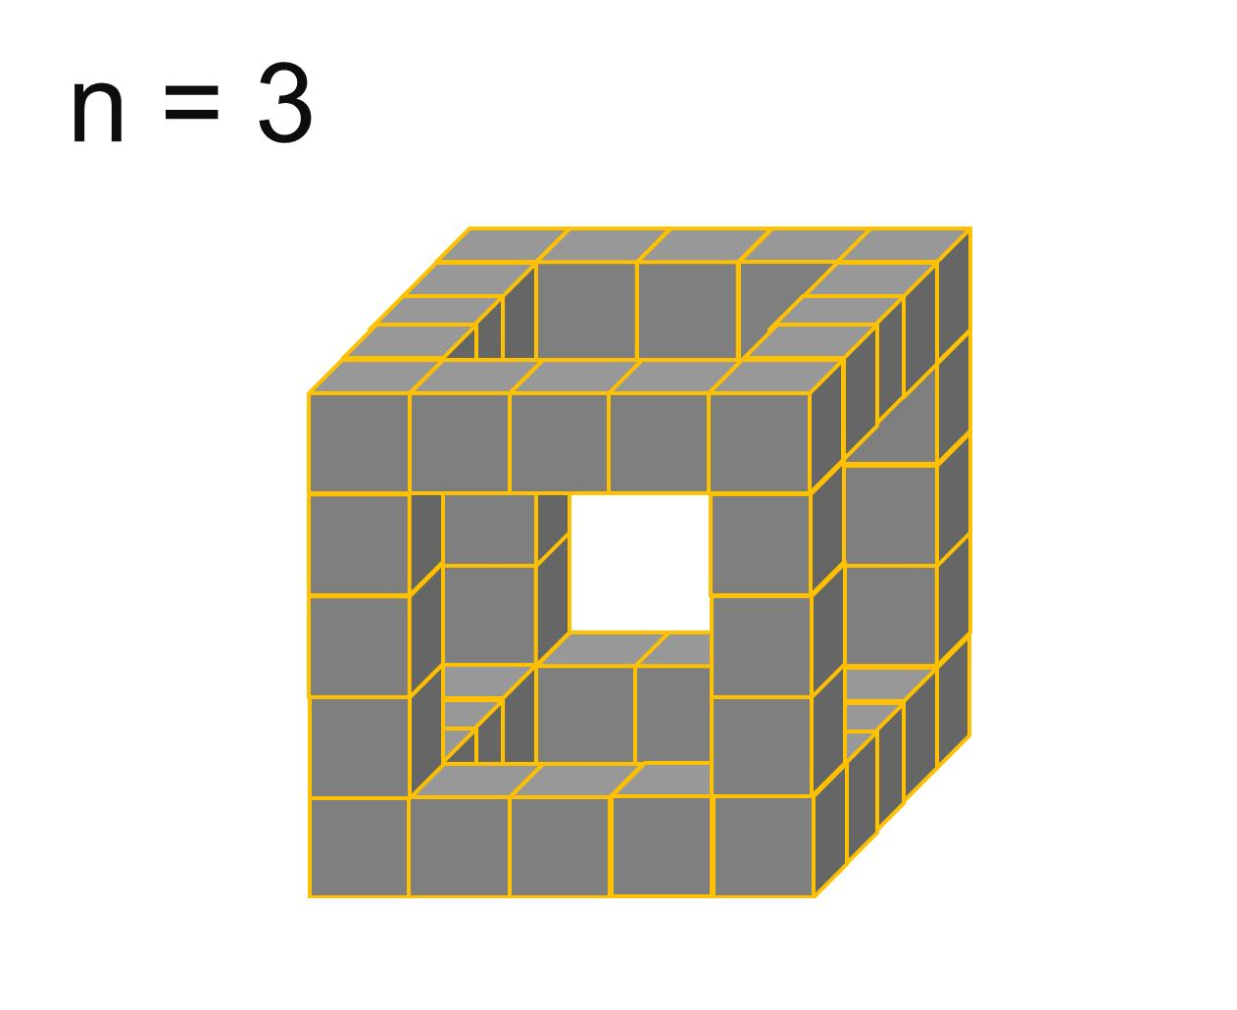
Formed by arranging cubes around an empty internal region or opening.
Examples:
- Hollow cube frame.
- Hollow rectangular frame.
- Hollow square arrangement.
- Multi-layer hollow structure.

Symmetrical Cube-Based Composite Solids
# Source: AI Source: Provided by: [Data Path: Persons Table -> ID Column: 1, Name_En Column: Motasem Essam] -> From: [ChatGPT] on [7/25/2026]
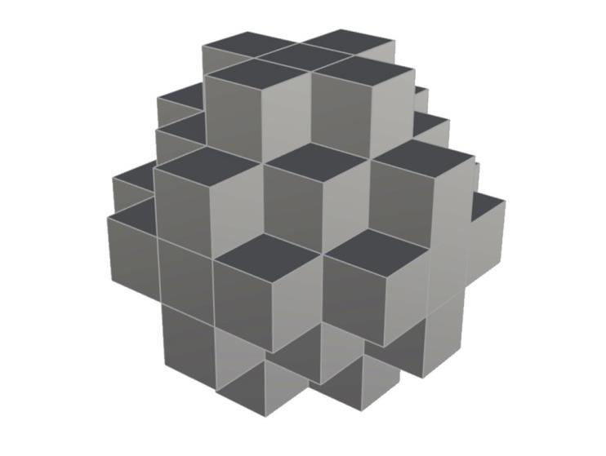
Formed by arranging cubes so that the overall structure has one or more symmetry properties.
Examples:
- Reflection-symmetrical arrangement.
- Rotationally symmetrical arrangement.
- Axially symmetrical arrangement.
- Centrally balanced arrangement.

Irregular Cube-Based Composite Solids
# Source: AI Source: Provided by: [Data Path: Persons Table -> ID Column: 1, Name_En Column: Motasem Essam] -> From: [ChatGPT] on [7/25/2026]
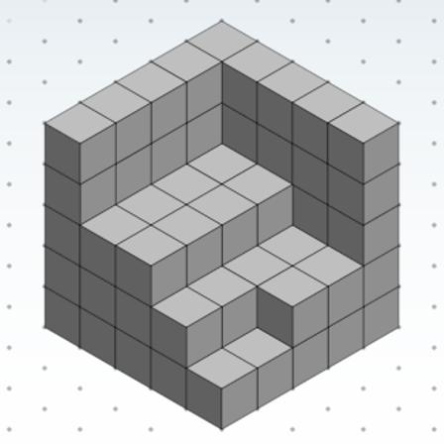
Formed by joining cubes in a non-uniform arrangement without a regular overall pattern.
Examples:
- Random cube arrangement.
- Uneven multi-level arrangement.
- Asymmetrical arrangement.
- Complex interlocking arrangement.

Classification by Cube Arrangement
# Source: AI Source: Provided by: [Data Path: Persons Table -> ID Column: 1, Name_En Column: Motasem Essam] -> From: [ChatGPT] on [7/25/2026]
Cube-based repeated composite solids can also be classified according to how their cubes are positioned and connected.
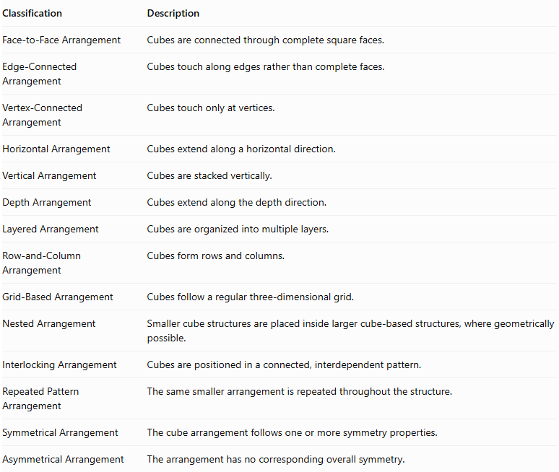
Classification | Description
Face-to-Face Arrangement | Cubes are connected through complete square faces.
Edge-Connected Arrangement | Cubes touch along edges rather than complete faces.
Vertex-Connected Arrangement | Cubes touch only at vertices.
Horizontal Arrangement | Cubes extend along a horizontal direction.
Vertical Arrangement | Cubes are stacked vertically.
Depth Arrangement | Cubes extend along the depth direction.
Layered Arrangement | Cubes are organized into multiple layers.
Row-and-Column Arrangement | Cubes form rows and columns.
Grid-Based Arrangement | Cubes follow a regular three-dimensional grid.
Nested Arrangement | Smaller cube structures are placed inside larger cube-based structures, where geometrically possible.
Interlocking Arrangement | Cubes are positioned in a connected, interdependent pattern.
Repeated Pattern Arrangement | The same smaller arrangement is repeated throughout the structure.
Symmetrical Arrangement | The cube arrangement follows one or more symmetry properties.
Asymmetrical Arrangement | The arrangement has no corresponding overall symmetry.
Important distinction: Cubes connected only along an edge or vertex may form a touching collection, but they do not necessarily create one continuous solid. Face-to-face connection is the usual arrangement for a solid composite structure.

Classification by Number and Size of Cubes
# Source: AI Source: Provided by: [Data Path: Persons Table -> ID Column: 1, Name_En Column: Motasem Essam] -> From: [ChatGPT] on [7/25/2026]
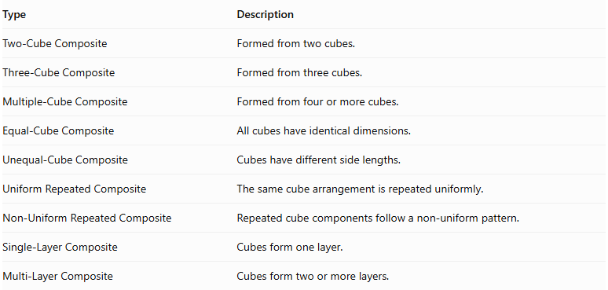
Type | Description
Two-Cube Composite | Formed from two cubes.
Three-Cube Composite | Formed from three cubes.
Multiple-Cube Composite | Formed from four or more cubes.
Equal-Cube Composite | All cubes have identical dimensions.
Unequal-Cube Composite | Cubes have different side lengths.
Uniform Repeated Composite | The same cube arrangement is repeated uniformly.
Non-Uniform Repeated Composite | Repeated cube components follow a non-uniform pattern.
Single-Layer Composite | Cubes form one layer.
Multi-Layer Composite | Cubes form two or more layers.

Mathematical Properties and Formulas

Volume
# Source: AI Source: Provided by: [Data Path: Persons Table -> ID Column: 1, Name_En Column: Motasem Essam] -> From: [ChatGPT] on [7/25/2026]
The volume of one cube is:
$$V_{cube}=a^{3}$$
Where:
- $a$ = side length of the cube.
For a composite solid containing $n$ equal cubes that do not overlap:
$$\boxed{V_{total}={na}^{3}}$$
Where:
- $n$ = number of cubes.
- $a$ = side length of each cube.
If the cubes have different dimensions:
$$V_{total}=\sum_{i=1}^{n}{a_{i}^{3}}$$
This assumes the cubes form a non-overlapping collection.

Surface Area
# Source: AI Source: Provided by: [Data Path: Persons Table -> ID Column: 1, Name_En Column: Motasem Essam] -> From: [ChatGPT] on [7/25/2026]
The total surface area of one cube is:
$${SA}_{cube}=6a^{2}$$
If $n$ separate cubes were not joined, their combined surface area would be:
$${SA}_{separate}=6{na}^{2}$$
However, when cubes are joined face-to-face, the connected faces become hidden and must not be counted as external surfaces.
For equal cubes connected through complete square faces:
$$\boxed{{SA}_{total}=(6n-2m)a^{2}}$$
Where:
- $n$ = total number of cubes.
- $m$ = number of shared face-to-face connections.
- $a$ = side length of each cube.
Each shared connection hides two square faces, which explains the subtraction of $2{ma}^{2}$.

Number of Exposed Faces
# Source: AI Source: Provided by: [Data Path: Persons Table -> ID Column: 1, Name_En Column: Motasem Essam] -> From: [ChatGPT] on [7/25/2026]
For a face-connected arrangement of equal cubes:
$$\boxed{F_{exposed}=6n-2m}$$
Therefore:
$${SA}_{total}=F_{exposed}a^{2}$$

Special Formula for a Rectangular Block
# Source: AI Source: Provided by: [Data Path: Persons Table -> ID Column: 1, Name_En Column: Motasem Essam] -> From: [ChatGPT] on [7/25/2026]
For a rectangular block made of equal cubes, let:
- $l$ = number of cubes along its length.
- $w$ = number of cubes along its width.
- $h$ = number of cubes along its height.
- $a$ = side length of each cube.
Number of cubes:
$$n=lwh$$
Volume:
$$\boxed{V=lwh,a^{3}}$$
External surface area:
$$\boxed{SA=2a^{2}(lw+lh+wh)}$$
The overall dimensions of the block are $la$, $wa$, and $ha$.

Worked Examples

Example 1: Linear Cube-Based Composite Solid
# Source: AI Source: Provided by: [Data Path: Persons Table -> ID Column: 1, Name_En Column: Motasem Essam] -> From: [ChatGPT] on [7/25/2026]
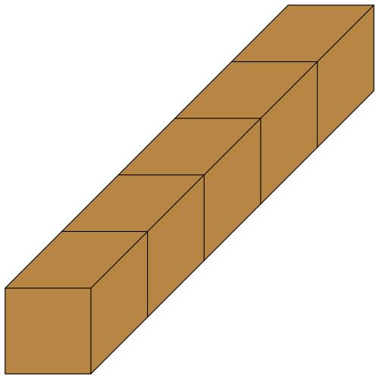
Given:
- Number of cubes: $n=4$
- Side length: $a=2 cm$
- Arrangement: one straight row.
Step 1: Calculate the total volume.
$$V={na}^{3}$$
$$V=4(2^{3})$$
$$V=4(8)=32$$
<badge color="success">Volume = 32 cm³</badge>
Step 2: Calculate the number of shared faces.
Four cubes in one row have three shared face connections:
$$m=4-1=3$$
Step 3: Calculate the external surface area.
$$SA=(6n-2m)a^{2}$$
$$SA=(6(4)-2(3))(2^{2})$$
$$SA=(24-6)(4)$$
$$SA=18(4)=72$$
<badge color="success">Surface Area = 72 cm²</badge>
Final Result:
- Total Volume = $32{ cm}^{3}$
- External Surface Area = $72{ cm}^{2}$

Example 2: Rectangular Block Cube-Based Composite Solid
# Source: AI Source: Provided by: [Data Path: Persons Table -> ID Column: 1, Name_En Column: Motasem Essam] -> From: [ChatGPT] on [7/25/2026]
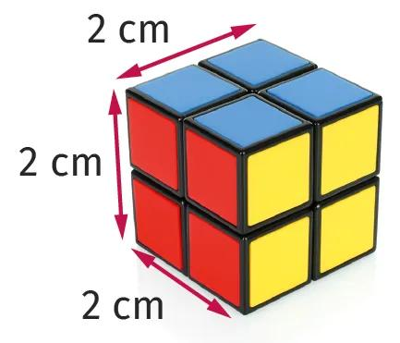
Given:
- Length: $l=2$ cubes.
- Width: $w=2$ cubes.
- Height: $h=2$ cubes.
- Side length of each cube: $a=3 cm$.
Step 1: Calculate the number of cubes.
$$n=lwh$$
$$n=2×2×2=8$$
Step 2: Calculate the total volume.
$$V={na}^{3}$$
$$V=8(3^{3})$$
$$V=8(27)=216$$
<badge color="success">Volume = 216 cm³</badge>
Step 3: Calculate the external surface area.
Use the rectangular block formula:
$$SA=2a^{2}(lw+lh+wh)$$
$$SA=2(3^{2})(2(2)+2(2)+2(2))$$
$$SA=18(4+4+4)$$
$$SA=18(12)=216$$
<badge color="success">Surface Area = 216 cm²</badge>
Final Result:
- Total Volume = $216{ cm}^{3}$
- External Surface Area = $216{ cm}^{2}$

Important Characteristics
# Source: AI Source: Provided by: [Data Path: Persons Table -> ID Column: 1, Name_En Column: Motasem Essam] -> From: [ChatGPT] on [7/25/2026]
- Repeated Components: The structure contains multiple cube components.
- Uniform Geometry: Equal-cube arrangements use the same side length for every cube.
- Face Connections: Cubes commonly join through square faces.
- Three-Dimensional Structure: Cubes can extend along length, width, and height.
- Variable Arrangements: The same cubes can form different overall structures.
- Hidden Surfaces: Joining faces are excluded from the external surface area.
- Additive Volume: The total volume is the sum of the individual cube volumes when they do not overlap.
- Different Symmetry Properties: The resulting structure may be symmetrical or asymmetrical.
- Expandable Structure: Additional cubes can extend an existing arrangement.
- Discrete Construction: The structure can be analyzed by counting its individual cubes.

Comparison with Other Repeated Composite Solids
# Source: AI Source: Provided by: [Data Path: Persons Table -> ID Column: 1, Name_En Column: Motasem Essam] -> From: [ChatGPT] on [7/25/2026]
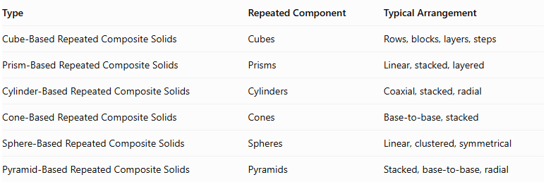
Type | Repeated Component | Typical Arrangement
Cube-Based Repeated Composite Solids | Cubes | Rows, blocks, layers, steps
Prism-Based Repeated Composite Solids | Prisms | Linear, stacked, layered
Cylinder-Based Repeated Composite Solids | Cylinders | Coaxial, stacked, radial
Cone-Based Repeated Composite Solids | Cones | Base-to-base, stacked
Sphere-Based Repeated Composite Solids | Spheres | Linear, clustered, symmetrical
Pyramid-Based Repeated Composite Solids | Pyramids | Stacked, base-to-base, radial
Main distinction: Cube-based repeated composite solids use cubes as their repeated building components, allowing their structures to be analyzed through square faces, equal edge lengths, and shared-face connections.

Applications
# Source: AI Source: Provided by: [Data Path: Persons Table -> ID Column: 1, Name_En Column: Motasem Essam] -> From: [ChatGPT] on [7/25/2026]
Cube-based repeated composite solids are used in several fields:
- Architecture: Designing modular structures and cubic building arrangements.
- Construction: Creating block-based structures and modular construction systems.
- Engineering: Studying connected components and three-dimensional arrangements.
- Mathematics Education: Teaching volume, surface area, spatial reasoning, and geometric patterns.
- Computer Graphics: Building voxel-based models and three-dimensional environments.
- Game Design: Creating block-based environments and structures.
- Industrial Design: Developing modular products and component arrangements.
- Puzzle Design: Constructing three-dimensional cube puzzles and spatial challenges.

Key Points
# Source: AI Source: Provided by: [Data Path: Persons Table -> ID Column: 1, Name_En Column: Motasem Essam] -> From: [ChatGPT] on [7/25/2026]
- Cube-based repeated composite solids consist of multiple cubes joined into one structure.
- They can be arranged linearly, in rectangular blocks, in layers, in steps, or in more complex patterns.
- Equal cubes have the same side length and volume.
- Total volume is calculated by adding the volumes of all non-overlapping cubes.
- External surface area excludes hidden joining faces.
- For equal cubes connected face-to-face:
$$V={na}^{3}$$
$$SA=(6n-2m)a^{2}$$
- The overall shape depends on the number, size, and arrangement of its cubes.

Conclusion
# Source: AI Source: Provided by: [Data Path: Persons Table -> ID Column: 1, Name_En Column: Motasem Essam] -> From: [ChatGPT] on [7/25/2026]
Cube-Based Repeated Composite Solids are three-dimensional structures formed by combining multiple cubes in repeated arrangements. They include linear structures, rectangular blocks, layered structures, stepped forms, hollow arrangements, symmetrical structures, and irregular configurations.
Their mathematical properties are based mainly on cube volume, square-face area, and the number of shared connections between components. Understanding these structures provides a foundation for studying more complex repeated composite solids and three-dimensional geometric arrangements.

